ASC REPORT: Hov/2024 | 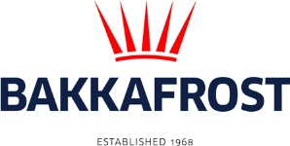

Site info
ASC certification | 11-10-2019
Start of production cycle | 13-04-2024
End of production cycle
Report last updated | 21-06-2024
Estimated unexplained loss

Wildlife interactions – overview | Number
Birds | 0
Mammals | 0
Number of escaped fish | 0

Wildlife interactions –birds
Date of incident | Number | Species | Cause
N/A | 0

Wildlife interactions – mammals
Date of incident | Number | Species | Cause
N/A | 0

Wildlife interactions – Fish escapes
Date of incident | Number | Cause
N/A | 0

Fish Health Surveillance
Suspicious Unidentifiable transmissible agent | None
Detection of OIE – notifiable disease | None

Lice
Date | Average lice number  (number of mature female/fish) | Average lice number  (number of motile/fish)
07-05-2024 | 0,00 | 0,00
17-05-2024 | 0,00 | 0,00
21-05-2024 | 0,00 | 0,00
28-05-2024 | 0,00 | 0,07
04-06-2024 | 0,00 | 0,30
11-06-2024 | 0,00 | 0,03
19-06-2024 | 0,09 | 0,30
27-06-2024 | 0,16 | 0,00

