ASC REPORT: Kolbeinargjógv A-81/2024 | 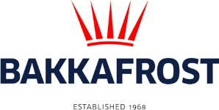

Site info
ASC certification | 07-10-2019
Start of production cycle | 23-07-2024
End of production cycle
Report last updated | 13-11-2024
Estimated unexplained loss

Wildlife interactions – overview | Number
Birds | 0
Mammals | 0
Number of escaped fish | 0

Wildlife interactions –birds
Date of incident | Number | Species | Cause
N/A | 0

Wildlife interactions – mammals
Date of incident | Number | Species | Cause
N/A | 0

Wildlife interactions – Fish escapes
Date of incident | Number | Cause
N/A | 0

Fish Health Surveillance
Suspicious Unidentifiable transmissible agent | None
Detection of OIE – notifiable disease | None
Lice
Date | Average lice number  (number of mature female/fish) |  | Average lice number  (number of motile/fish)
26-07-2024 | 0,00 |  | 0,01
05-08-2024 | 0,01 |  | 0,14
12-08-2024 | 0,04 |  | 0,01
26-08-2024 | 0,05 |  | 0,25
09-09-2024 | 0,21 |  | 0,30
23-09-2024 | 0,13 |  | 0,09
04-10-2024 | 0,07 |  | 0,10
18-10-2024 | 0,16 |  | 0,19
28-10-2024 | 0,44 |  | 1,34
04-11-2024 | 0,71 |  | 0,64
13-11-2024 | 0,96 |  | 0,66

