ASC REPORT: Lambavík / 2024 | 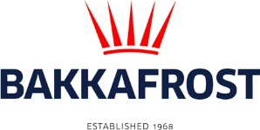

Site info
ASC certification | 16-11-2018
Start of production cycle | 10-03-2024
End of production cycle
Report last updated | 21-06-2024
Estimated unexplained loss/gain

Wildlife interactions - overview | Number
Birds | 0
Mammals | 0
Number of escaped fish | 0

Wildlife interactions -birds
Date of incident | Number | Species | Cause
N/A | 0

Wildlife interactions - mammals
Date of incident | Number | Species | Cause
N/A | 0

Wildlife interactions - Fish escapes
Date of incident | Number | Cause
N/A | 0

Fish Health Surveillance
Suspicious Unidentifiable transmissible agent | None
Detection of OIE – notifiable disease | None

Lice
Date | Average lice number  (number of mature female/fish) | Average lice number  (number of motile/fish)
03-04-2024 | 0,00 | 0,00
17-04-2024 | 0,00 | 0,03
01-05-2024 | 0,00 | 0,17
09-05-2024 | 0,00 | 0,01
15-05-2024 | 0,01 | 0,47
29-05-2024 | 0,17 | 0,54
12-06-2024 | 0,22 | 0,47
20-06-2024 | 0,20 | 0,29
26-06-2024 | 0,16 | 0,65

