ASC REPORT: Gøtuvík N A-47/ 2024 | 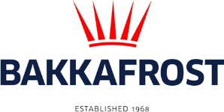

Site info
ASC certification | 29-10-2020
Start of production cycle | 25-06-2024
End of production cycle
Report last updated | 11-07-2024
Estimated unexplained gain

Wildlife interactions - overview | Number
Birds | 0
Mammals | 0
Number of escaped fish | 0

Wildlife interactions -birds
Date of incident | Number | Species | Cause
N/A | 0

Wildlife interactions - mammals
Date of incident | Number | Species | Cause
N/A | 0

Wildlife interactions - Fish escapes
Date of incident | Number | Cause
N/A | 0

Fish Health Surveillance
Suspicious Unidentifiable transmissible agent |  | None
Detection of OIE – notifiable disease |  | None
Lice
Date | Average lice number  (number of mature female/fish) |  | Average lice number  (number of motile/fish)
28-06-2024 | 0,00 |  | 0,16
05-07-2024 | 0,00 |  | 0,00
11-07-2024 | 0,00 |  | 0,00

