ASC REPORT: Borðoyarvík / 2024 | 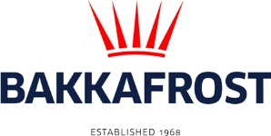

Site info
ASC certification | 16-11-2018
Start of production cycle | 19-02-2024
End of production
Report last updated | 12-04-2024
Estimated unexplained gain

Wildlife interactions - overview | Number
Birds | 0
Mammals | 0
Number of escaped fish | 0

Wildlife interactions -birds
Date of incident | Number | Species | Cause
N/A | 0

Wildlife interactions - mammals
Date of incident | Number | Species | Cause
N/A | 0

Wildlife interactions - Fish escapes
Date of incident | Number | Cause
N/A | 0

Fish Health Surveillance
Suspicious Unidentifiable transmissible agent |  | None
Detection of OIE – notifiable disease |  | None
Lice
Date | Average lice number  (number of mature female/fish) |  | Average lice number  (number of motile/fish)
14-03-2024 | 0,00 |  | 0,00
26-03-2024 | 0,00 |  | 0,00
09-04-2024 | 0,00 |  | 0,05

