ASC REPORT: Vágur / 2024 | 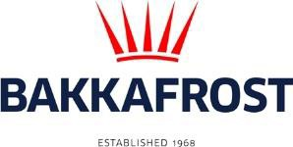

Site info
ASC certification | 27-09-2019
Start of production cycle | 03-05-2024
End og production cycle
Report last updated | 24-05-2024
Estimated unexplained gain

Wildlife interactions - overview | Number
Birds | 0
Mammals | 0
Number of escaped fish | 0

Wildlife interactions -birds
Date of incident | Number | Species | Cause
N/A | 0

Wildlife interactions - mammals
Date of incident | Number | Species | Cause
N/A | 0

Wildlife interactions - Fish escapes
Date of incident | Number | Cause
N/A | 0

Fish Health Surveillance
Suspicious Unidentifiable transmissible agent | None
Detection of OIE – notifiable disease | None

Lice
Date | Average lice number  (number of mature female/fish) | Average lice number  (number of motile/fish)
07-05-2024 | 0,15 | 0,21
13-05-2024 | 0,23 | 0,31
21-05-2024 | 0,03 | 0,14

