ASC REPORT: Undir Síðu A-05/2024 | 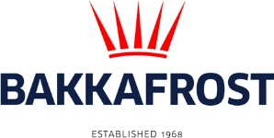

Site info
ASC certification | 07-10-2019
Start of production cycle | 20-05-2024
End of production cycle
Report last updated | 21-06-2024
Estimated unexplained loss

Wildlife interactions – overview | Number
Birds | 0
Mammals | 0
Number of escaped fish | 0

Wildlife interactions –birds
Date of incident | Number | Species | Cause
N/A | 0

Wildlife interactions – mammals
Date of incident | Number | Species | Cause
N/A | 0

Wildlife interactions – Fish escapes
Date of incident | Number | Cause
N/A | 0

Fish Health Surveillance
Suspicious Unidentifiable transmissible agent | None
Detection of OIE – notifiable disease | None

Lice
Date | Average lice number  (number of mature female/fish) |  | Average lice number  (number of motile/fish)
22-05-2024 | 0,00 |  | 0,00
29-05-2024 | 0,00 |  | 0,01
03-06-2024 | 0,03 |  | 0,01
17-06-2024 | 0,03 |  | 0,06
27-06-2024 | 0,07 |  | 0

