ASC REPORT: Árnafjørður / 2024 | 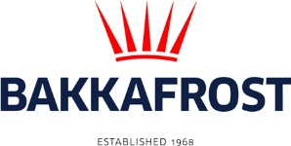

Site info
ASC certification | 01-09-2020
Start of production cycle | 30-04-2024
End of production
Report last updated | 21-06-2024
Unexplained loss

Wildlife interactions – overview | Number
Birds | 0
Mammals | 0
Number of escaped fish | 0

Wildlife interactions -birds
Date of incident | Number | Species | Cause
N/A | 0

Wildlife interactions – mammals
Date of incident | Number | Species | Cause
N/A | 0

Wildlife interactions – Fish escapes
Date of incident | Number | Cause
Na | 0

Fish Health Surveillance
Suspicious Unidentifiable transmissible agent |  | None
Detection of OIE – notifiable disease |  | None
Lice
Date | Average lice number  (number of mature female/fish) |  | Average lice number  (number of motile/fish)
03-05-2024 | 0,00 |  | 0,00
17-05-2024 | 0,00 |  | 0,00
24-05-2024 | 0,00 |  | 0,00
31-05-2024 | 0,00 |  | 0,01
07-06-2024 | 0,00 |  | 0,00
14-06-2024 | 0,00 |  | 0,01
19-06-2024 | 0,00 |  | 0,05
26-06-2024 | 0,00 |  | 0,12

